# TSP Experiment Detailed Report

This report provides a detailed evaluation of three constructive methods (Cheapest Insertion, Nearest Neighbour, Greedy Heuristic) and their heuristic enhancements (2-opt, Node Shift, and Node Swap). Data is analyzed for TSP files with increasing node sizes.

## Graph 1: Time vs Number of Nodes (Constructive Methods)

Analysis: Greedy Heuristic took the most time for larger instances, while Nearest Neighbour and Cheapest Insertion were faster. This is due to Greedy's exhaustive exploration of possible routes.

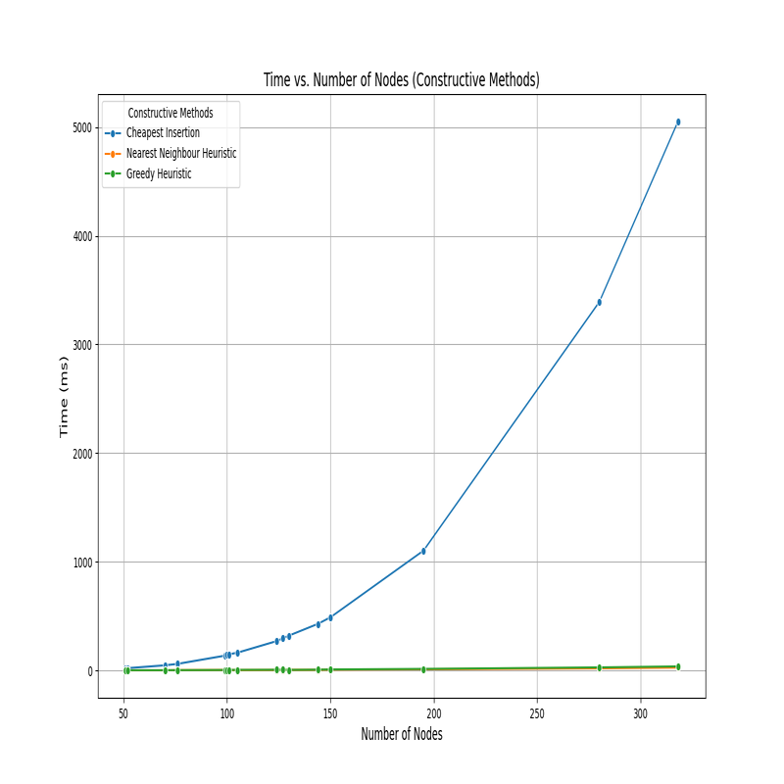

## Graph 2: Time vs Number of Nodes (Perturbative Methods)

Analysis: 2-opt was the quickest perturbative method for all instances, followed by Node Swap. Node Shift consistently took the longest time, especially as node counts increased.

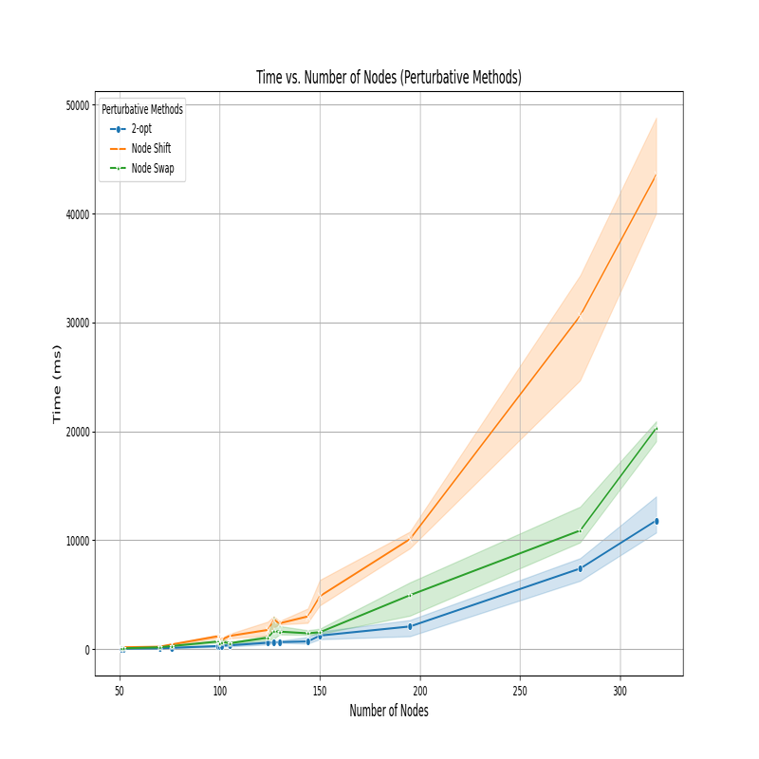

## Graph 3: Cost vs Number of Nodes (Constructive Methods)

Analysis: Greedy Heuristic consistently produced the best initial solutions (lowest costs), especially as the number of nodes increased. Cheapest Insertion and Nearest Neighbour showed comparable performance for smaller instances.

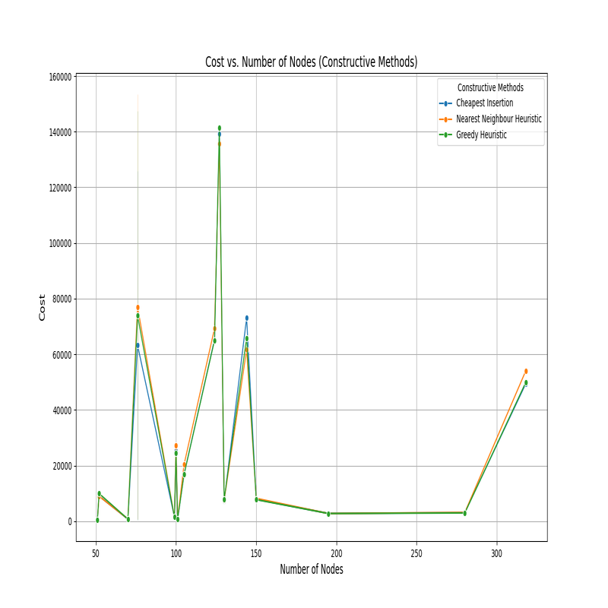

## Graph 4: Cost vs Number of Nodes (Perturbative Methods)

Analysis: 2-opt demonstrated the most significant cost reductions across all instances, making it the most effective perturbative method. Node Shift and Node Swap provided incremental improvements but lagged behind 2-opt in terms of cost optimization.

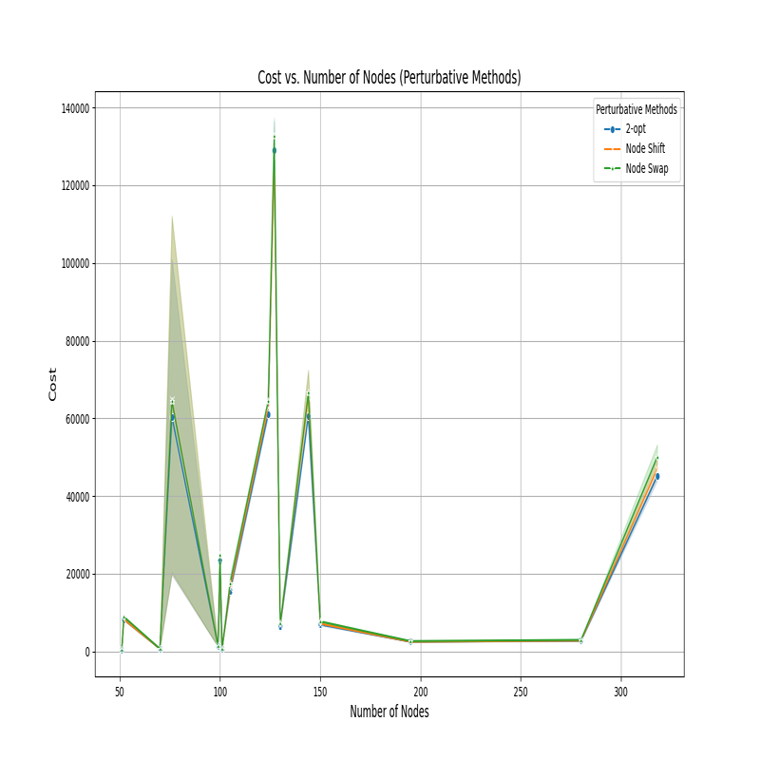

# TSP Experiment Averages Report

## Constructive Methods Average Times and Costs

The table below summarizes the average time and cost for each constructive method.

|  |  |  |
| --- | --- | --- |
| Method | Average Time (ms) | Average Cost |
| Cheapest Insertion | 576.95 | 28690.41 |
| Greedy Heuristic | 5.95 | 29297.77 |
| Nearest Neighbour Heuristic | 4.27 | 30298.86 |

## Perturbative Methods Average Times and Costs

The table below summarizes the average time and cost for each perturbative method enhancement.

|  |  |  |  |  |  |  |
| --- | --- | --- | --- | --- | --- | --- |
| Method | Avg 2-opt Time (ms) | Avg 2-opt Cost | Avg Node Shift Time (ms) | Avg Node Shift Cost | Avg Node Swap Time (ms) | Avg Node Swap Cost |
| Cheapest Insertion | 1491.95 | 27065.68 | 4859.09 | 27113.45 | 2372.64 | 28043.77 |
| Greedy Heuristic | 1117.23 | 26010.32 | 4584.27 | 26760.59 | 2120.05 | 28308.23 |
| Nearest Neighbour Heuristic | 1186.50 | 25919.59 | 5389.73 | 27545.86 | 2224.36 | 27891.68 |

Analysis of TSP Methods

This document provides an analysis of various TSP methods including Constructive Heuristics and Perturbative Methods. The analysis includes deviation versus nodes comparison and the average deviation for each method.

# Constructive Methods

|  |  |
| --- | --- |
| Method | Average Deviation (%) |
| Cheapest Insertion | 5.28 |
| Greedy Heuristic | 8.28 |
| Nearest Neighbour Heuristic | 14.46 |

# Perturbative Methods

|  |  |
| --- | --- |
| Method | Average Deviation (%) |
| Method + 2-opt | 2.00 |
| Method + Node Shift | 5.49 |
| Method + Node Swap | 4.57 |

## Constructive Methods: Average Deviation vs. Node

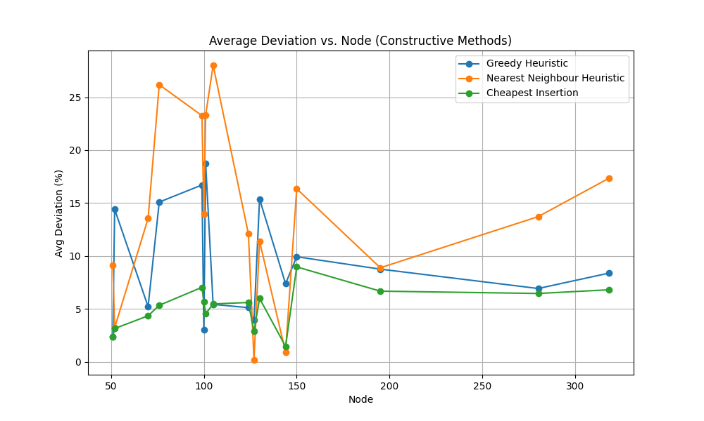

## Perturbative Methods: Average Deviation vs. Node

